DR17YC [0,8 mm]
DR17TC
DR15ZC

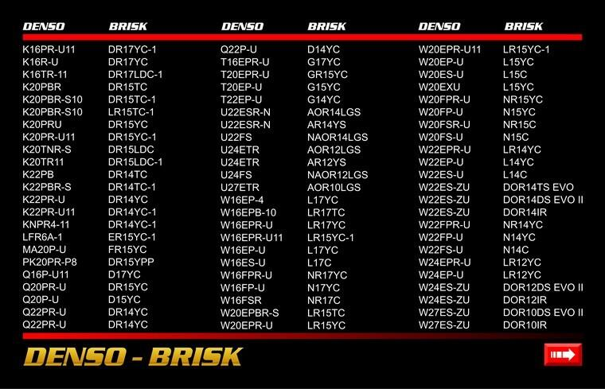
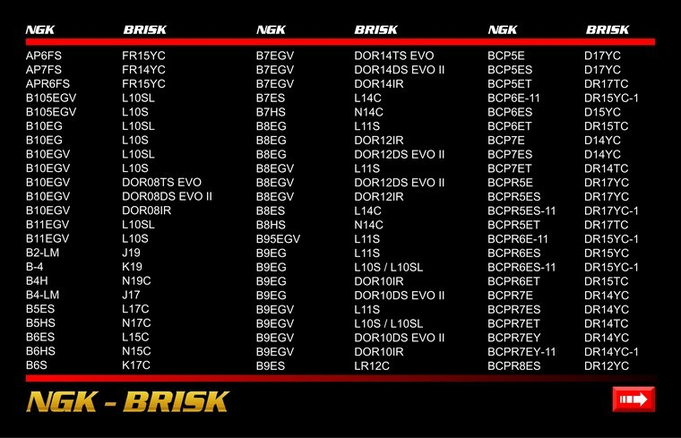
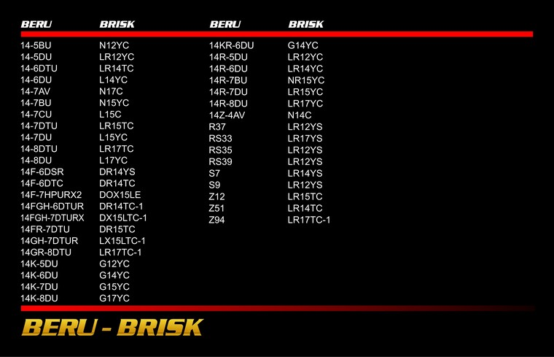
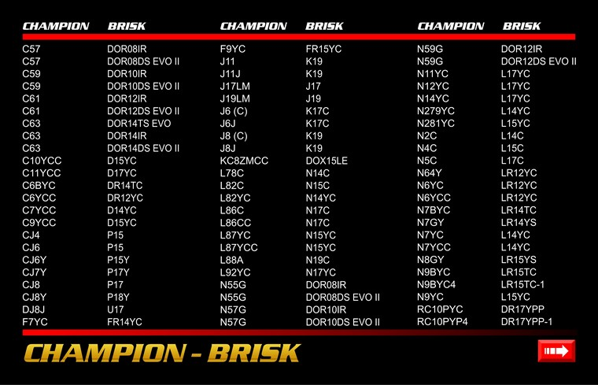
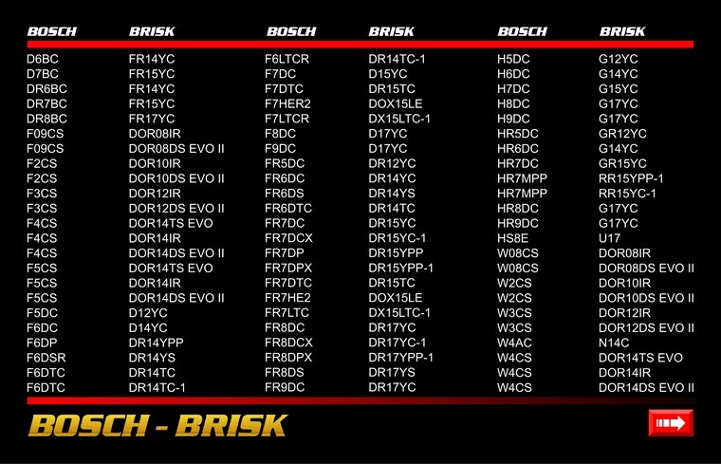
DR17YC- FR8DC

Аналоги: 000018F203; 0031596703; 12121705914; 14FR8DUX; 1UNC18110; 1UXC18110; 2240112E14; 22401V5085; 9091901122; 9091901129; 9091901151; 9091901152; 9091901158; 9116385; 9807955140; 9807955147; 9807955148; 9807955149; 980795514B; 980795514F; 99906910P9021; 99906910P9022; 99906910X9004; B6B318110; BCP5E11; BCP5ES; BCP5ES11; BCP5EY11; BCPR5E; BCPR5E11; BCPR5EIX11; BCPR5EIX11P; BCPR5EP11; BCPR5EP13; BCPR5EP8; BCPR5ES; BCPR5ES11; BCPR5EVX11; BCPR5EY11; BCPR5EY11_TP; BY481BCPR5; BY483BCPR5; F20318110; F8DCX; FR3LM; JE2618110; JF0318110; MZ602063; MZ602078; PFR5A11; PFR5K11; PQ16R; PQ16R13; PQ16R8; Q16PRU; Q16PRU11; Q16PU11; Q16RU; Q16RU11; Q16U; Q16U11; VQ16; Z73; ZFR5A11;

FR8DPX 1.1

FR8D+, FR8DC+

Beru #Z79

